Challenges doucument
1.Jenkin install in aws ec2 Linux.
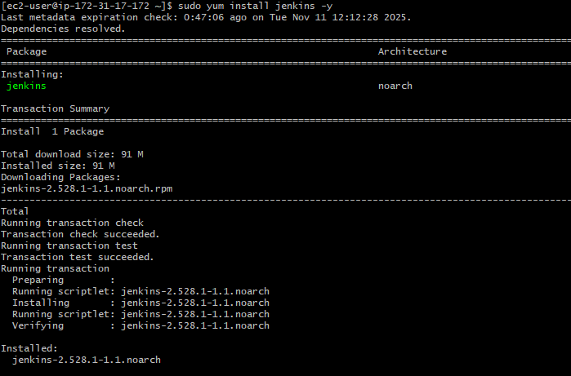
2. Setup Apache Tomcat on ec2.
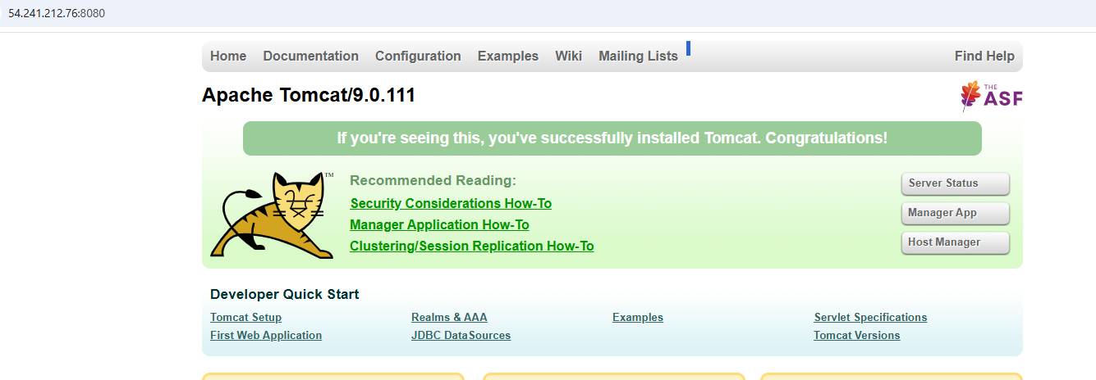

3.Setup Docker Desktop on your local windows.
